PLEASE MAKE SURE TO READY EACH OF INSTRUCTION FROM THE START TO END

Step 1: Preparations

Before you start, make sure you have:

A working computer with an internet connection.

A USB flash drive with at least 8 GB of storage capacity.

Sufficient free space on your computer's hard drive.

Step 2: Download the Media Creation Tool

<https://www.microsoft.com/en-us/software-download/windows10>

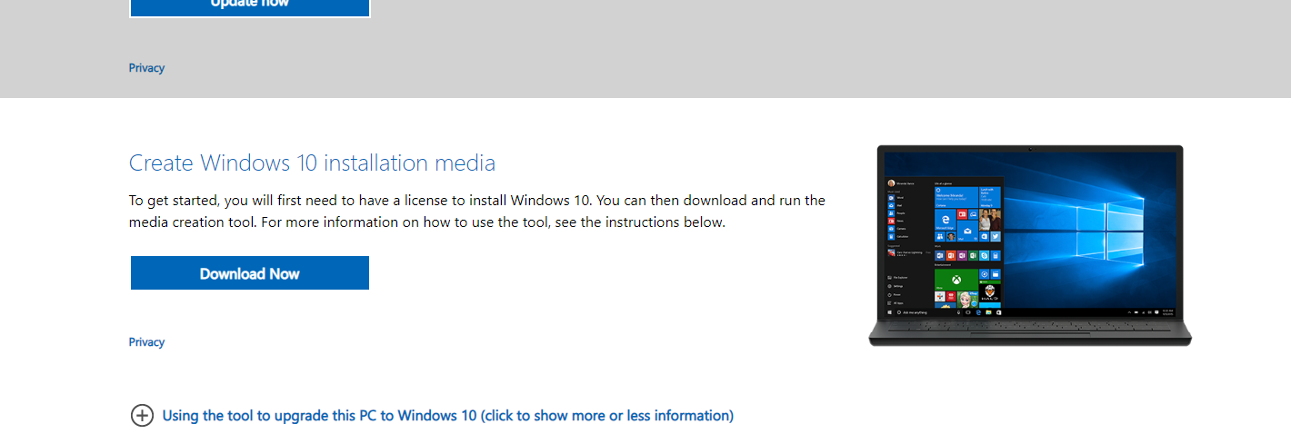

Click on the link to go to the Microsoft website.

Step 3: Download the Windows 10 Installation Tool

Once you click the download link, a new page will open.

Find and click on a button or link that says "Download Now" or something similar.

A file download prompt will appear. Click "Save" or "Save File" to download the tool.

Wait for the download to complete. It may take a few minutes depending on your internet speed.

Step 4: Run the Media Creation Tool

After the download is finished, go to your computer's "Downloads" folder.

Look for a file named "MediaCreationTool.exe" or something similar.

Double-click on the file to run it. You might see a warning message; click "Yes" or "Run" to proceed.

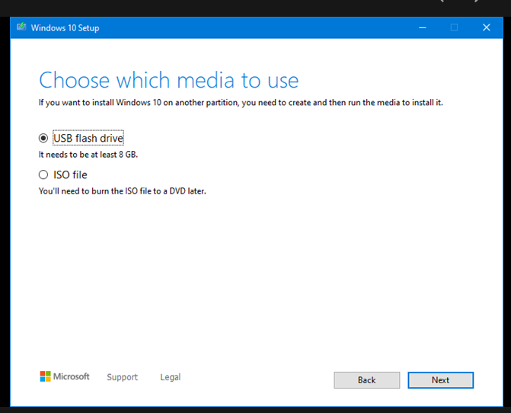

Step 5: Accept the License Terms

In the Media Creation Tool window, you will see a screen with some text and a "License terms" button. Click "License terms."

Read through the license terms (or skip if you don't want to read them), and then click "Accept."

Step 6: Choose What to Do

You'll be asked what you want to do. Select "Create installation media for another PC" and click "Next."

Step 7: Choose Language, Edition, and Architecture

Choose your preferred language, edition, and architecture (32-bit or 64-bit). For most users, it's best to leave these options at their default settings.

Click "Next."

Step 8: Choose the Media Type

Choose the "USB flash drive" option and click "Next." This will create a bootable Windows 10 installation USB.

Step 9: Insert USB Drive

Insert your USB flash drive into an available USB port on your computer. Make sure you don't have any important data on it because it will be formatted during the process.

Step 10: Select the USB Drive

In the tool, you'll see a list of available drives. Select the USB drive you just inserted by clicking on it.

Click "Next."

Step 11: Download and Create the Windows 10 Installation Media

The tool will download the necessary files and create a bootable Windows 10 installation USB drive. This process may take some time, so be patient.

Step 12: Completion

When the process is finished, you'll see a message that says "Your USB flash drive is ready." Click "Finish" to close the tool.

Congratulations! You've successfully created a bootable Windows 10 installation USB drive using the Media Creation Tool. You can now use this USB drive to install or repair Windows 10 on your computer if needed.

Step 13: Boot from the USB Drive

Restart your computer.

As your computer boots up, you'll need to press a specific key to access the boot options:F12,

You'll usually see a message briefly on the screen that tells you which key to press.

Press the appropriate key to enter the boot options.

In the boot options menu, select the USB drive as the boot device and press Enter.

Step 14: Windows Setup

Your computer will now boot from the USB drive, and you will see the Windows Setup screen.

Choose your language, time, and keyboard preferences, and then click "Next."

Step 15: Install Windows

Click "Install Now."

Step 16: Enter Your Product Key (if required)

Skip then next

Step 17: Accept the License Terms

Read and accept the license terms by checking the box and clicking "Next."

Step 18: Choose the Installation Type

Select "Custom: Install Windows only (advanced)."

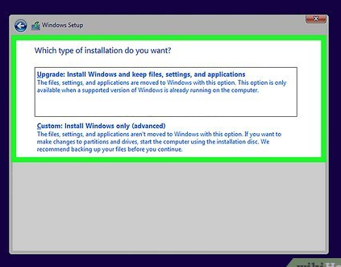

Step 19: Select a New, Empty Drive

In the Windows Setup screen, you should see a list of available disks and partitions.

Choose the unallocated space on the new, empty drive where you want to install Windows.

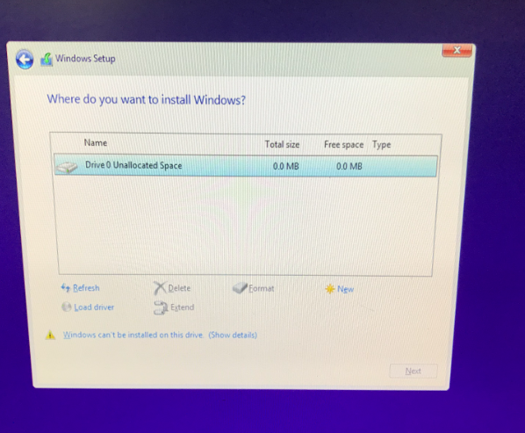

Step 21: Continue with the Installation

Click "Next."

Step 22: Complete the Setup

Follow the on-screen instructions to complete the Windows installation. This includes choosing your region, entering your username and password, and customizing other settings.

Step 23: Install Drivers and Updates

After Windows is set up, it's a good idea to install drivers for your hardware and run Windows Update to get the latest security updates and drivers from Microsoft.

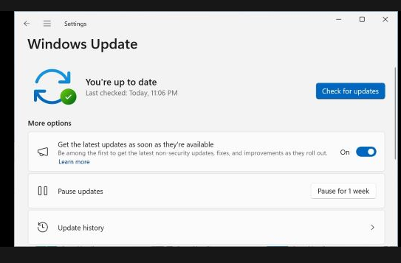

You have successfully installed Windows 10 on a new, empty drive and prepared it for use. Enjoy your fresh Windows installation!  
  
  
IF YOU ARE CONFUSED TO THE INSTRUCTIONS, FEEL FREE TO WATCH THIS EASY-WAY VIDEO TUTORIAL:  
<https://www.youtube.com/watch?v=R7VLs8FwD2M>